1.

Two sets which have no common members are known as ......
A.
equal sets
B.
equivalent sets
C.
empty sets
D.
disjoint sets
E.
union

2.

P = {0, 2, 4, 6} and Q = {1, 2, 4, 5}. Find P ∩ Q.
A.
{0, 6}
B.
{2, 4}
C.
{0, 4}
D.
{0, 2, 6}
E.
{0, 1, 2, 4, 5}

3.

Evaluate
1
2
[(4 – 1) – (5 – 6)]
A.
–4.0
B.
1.0
C.
2.0
D.
3.0
E.
4.0

4.

Find the highest(greatest) common factor of 35 and 70.
A.
5
B.
7
C.
10
D.
35
E.
70

5.

Write 1101101_{two} in base ten
A.
31
B.
43
C.
108
D.
109
E.
218

6.

State the property used in the statement: p(q + r) = pq + pr
A.
Associative
B.
Commutative
C.
Distributive
D.
Identity
E.
Universal

7.

If n² + 1 = 50, find n
A.
7
B.
24.5
C.
25
D.
49
E.
51
−
−
√

8.

Evaluate
0.63 x 0.70
9.00
A.
0.0049
B.
0.049
C.
0.49
D.
4.9
E.
49

9.

In the relation
1
R
=
1
R
1
+
1
R
2
, if R₁ = 1 and R₂ = 3,
find R
A.
1
2
B.
2
3
C.
3
4
D.
3
2
E.
4
3

10.

Arrange the following from the highest to the lowest:
2
3
, -9,
3
5
and 0.
A.
-9,
3
5
,
2
3
B.
-9, 0,
3
5
,
2
3
C.
3
5
,
2
3
, 0, -9
D.
3
5
,
2
3
, -9, 0
E.
2
3
,
3
5
, 0, -9

11.

The total numbers of goals scored each month by a football team are:
3, 4, 8, 2, 4, 6, 4, 8, 7 and 6.
What is the mode?
A.
2
B.
4
C.
5
D.
6
E.
8

12.

A trader sold 90 oranges at 3 for ₵50.00. How much did she get from selling all the oranges?
A.
₵1,500.00
B.
₵4,500.00
C.
₵6,000.00
D.
₵15,000.00
E.
₵45,000.00

13.

A man bought a car for ₵5.5 million and sold it for ₵6.5 million. Find the percentage gain.
A.
1.54%
B.
1.82%
C.
15.38%
D.
18.18%
E.
84.44%

14.

On a map, two towns P and Q are 15.5 cm apart. The scale of the map is 1 cm: 4 km. Calculate the actual distance between P and Q.
A.
15.5 km
B.
31 km
C.
46 km
D.
60 km
E.
62 km

15.

Expand the expression 2(3a + 2b)
A.
6a + 2b
B.
5a + 4b
C.
6a + 4b
D.
10ab
E.
12ab

16.

Mansah obtained 150 marks out of 240 marks in an English test. What was her percentage score?
A.
33.33%
B.
37.5%
C.
41.67%
D.
62.5%
E.
79.1%

17.

The marks obtained by six boys in a test are: 14, 20, 25, 15, 28 and 16. Find the mean mark.
A.
19.67
B.
22.00
C.
23.20
D.
26.40
E.
28.00

18.

Which of the following is equivalent to 2² × 6²
A.
2 × 3⁴
B.
2² × 3²
C.
2² × 3⁴
D.
2⁴ × 3
E.
2⁴ × 3²

19.

Kwaku had 300 mangoes. He sold 240 of them. What is the percentage of the mangoes left?
A.
8%
B.
20%
C.
25%
D.
26%
E.
80%

20.

A bag contains 5 black and 6 white balls. What is the probability of picking a white ball?
A.
1
11
B.
1
6
C.
1
5
D.
5
11
E.
6
11

21.

Solve for h in the equation 15 – 2h = 6
A.
–10.5
B.
–9.0
C.
–4.5
D.
4.5
E.
10.5

22.

What is the image of 3 in the mapping x → 3x + 7?
A.
10
B.
13
C.
16
D.
24
E.
34

23.

How many faces has a closed cylindrical object?
A.
1
B.
2
C.
3
D.
4
E.
34

24.

A graph of a straight line AB is shown below.
Use it to answer the question below
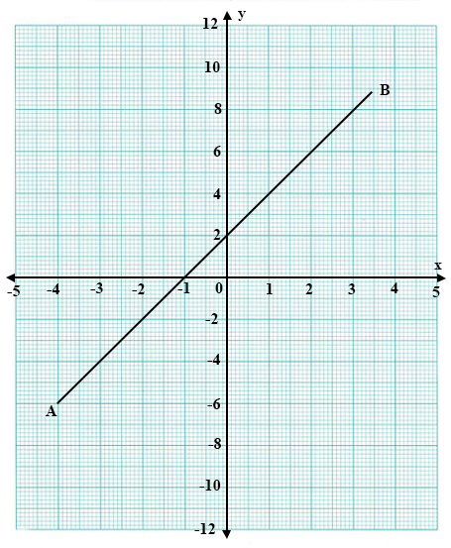
Find the gradient of the line AB
A.
1
B.
2
C.
3
D.
4
E.
5

25.

A graph of a straight line AB is shown below.
Use it to answer the question below
Find the coordinates of the point at which the line cuts the y-axis.
A.
(1, 0)
B.
(0, 1)
C.
(-1, 0)
D.
(0, -1)
E.
(0, 0)

26.

A man deposited an amount of ₵50,000.00 at a bank for 2 years at a rate of 20%. Find the simple interest.
A.
₵1,000.00
B.
₵2,000.00
C.
₵10,000.00
D.
₵20,000.00
E.
₵200,000.00

27.

Kofi received ₵800.00 commission on the sales he made on a particular day. This commission is 20% of sales he made. Calculate his total sales for the day.
A.
₵1,200.00
B.
₵2,400.00
C.
₵3,200.00
D.
₵4,000.00
E.
₵4,800.00

28.

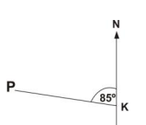
Calculate the bearing of town P from town K in the diagram below.
A.
005°
B.
085°
C.
095°
D.
265°
E.
275°

29.

In the diagram below, PQR is an isosceles triangle. |PQ| = |PR|, ∠QPR = 40° and QRS is a straight line.
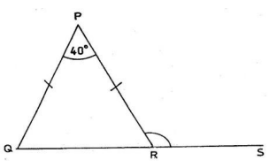
Find angle PRS.
A.
40°
B.
70°
C.
100°
D.
110°
E.
140°

30.

Factorize completely the expression 2xy – 8x + 5y - 20.
A.
(2x + 5)(y – 4)
B.
(2x – 5)(y + 4)
C.
(2x – 5)(y – 4)
D.
(2x + 5)(y + 4)
E.
(x + 5)(y – 4)

31.

Ama is facing east. Through how many degrees should she turn clockwise to face north?
A.
90°
B.
135°
C.
180°
D.
225°
E.
270°

32.

In the triangle RST, ∠RST is 90°, |RS| = 4 cm and |ST| = 3 cm.
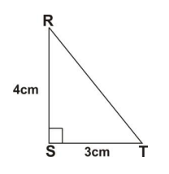
What is the length of RT?
A.
2 cm
B.
3 cm
C.
4 cm
D.
5 cm
E.
7 cm

33.

How many lines of symmetry has a rhombus?
A.
2
B.
3
C.
4
D.
5
E.
6

34.

Given that a =
(
-3
4
)
and b =
(
1
2
)
.
Find b - a.
A.
(
-2
6
)
B.
(
-4
2
)
C.
(
-3
8
)
D.
(
-2
2
)
E.
(
4
-2
)

35.

If u =
(
3
-1
)
and v =
(
6
1
)
, find 2u + v.
A.
(
12
0
)
B.
(
12
-1
)
C.
(
6
1
)
D.
(
6
0
)
E.
(
6
-1
)

36.

The volume of water in a cuboid is 9 m³. The length of the cuboid is 3 m and the breadth is 2 m.
Calculate the depth of water in the cuboid.
A.
0.15 m
B.
0.18 m
C.
1.5 m
D.
1.8 m
E.
6.0 m

37.

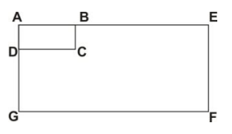
In the diagram above, rectangle AEFG is an enlargement of the rectangle ABCD. If |AB| = 5 cm and |AE| = 15 cm.
What is the scale factor of the enlargement?
A.
1
3
B.
1
2
C.
2
D.
3
E.
10

38.

In the diagram, O is the centre of the circle and r is its radius.
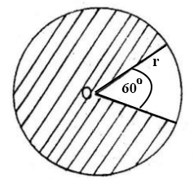
Calculate the area of the shaded region.
A.
1
6
πr²
B.
1
5
πr²
C.
1
3
πr²
D.
5
6
πr²
E.
7
12
πr²

39.

Which of the following best describes the statement: "The locus of points 6 cm from a fixed point O?"
A.
A parallel line 6 cm from O
B.
A vertical line 6 cm from point O
C.
A horizontal line 6 cm from point O
D.
An equilateral triangle of side 6 cm
E.
A circle with centre O and radius 6 cm

40.

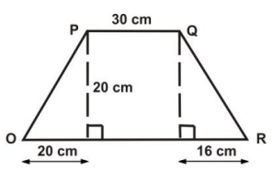
OPQR is a trapezium whose height is 20 cm. What is the area?
A.
460 cm²
B.
600 cm²
C.
920 cm²
D.
960 cm²
E.
1000 cm²

